**Year 8 Energy Fundamentals Quiz 1 Revision**

1. What is Energy?
2. What is another name for stored energy?
3. There are 3 main types of stored energy:
4. ______________________ eg. a stretched rubber band, windup toy.
5. ________________________ eg. candle (wax) is burning to give out light and heat
6. Gravitational Potential energy. eg._____________________________

________________________________________________________

1. What is the unit for energy?
2. How many joules in a kilojoule?
3. Convert:
4. 6 kJ to J____________________
5. 40 kJ to J___________________
6. 0.04 kJ to J__________________
7. 30,000 J to kJ____________________
8. 400 J to kJ___________________
9. How many joules in a mega joule?
10. Convert:
    1. 3 MJ to J____________________
    2. 16 MJ to J___________________
11. How many kilojoules in a mega joule?
12. Convert:
    1. 12 MJ to kJ____________________
    2. 20 MJ to kJ___________________
    3. 14 000 kJ to MJ____________________
    4. 7000 kJ to MJ___________________

Efficiency = Useful Energy Output x 100

Energy Input

1. Calculate the efficiency of a torch that uses 600 J of chemical potential energy to produce 40 J of light energy.
2. How much wasted energy is produced?
3. What is the main form of wasted energy produced?
4. If a petrol engine of a car is 25 %, how much kinetic energy will it produce when it uses a litre of fuel that contains 20 MJ of energy?
5. State the energy transformation:
   1. Using a torch
   2. talking on the phone
   3. green plants undergo photosynthesis
   4. Eating high energy food and drink, so that you can run faster.
6. Classify the following forms of energy as potential or action energy.

|  |  |  |  |  |  |  |  |
| --- | --- | --- | --- | --- | --- | --- | --- |
| gravitational | electrical | elastic | chemical | nuclear | light | sound | kinetic |

|  |  |
| --- | --- |
| Kinetic energy (doing energy) | Potential energy (stored) |
|  |  |
|  |  |
|  |  |
|  |  |
|  |  |

Kinetic energy is the energy an object has because of its mass and velocity(speed).

Ek= ½ mv2

Ek = kinetic energy(J)

m= mass (kg)

v= velocity (m/s)

1. Calculate the kinetic energy of a 2 kg rock that has fallen off a ledge and is travelling at 20 m/s. Show full working out.

1. Calculate the kinetic energy of a 20 gram bullet travelling at 115 m/s. Show full working out.
2. 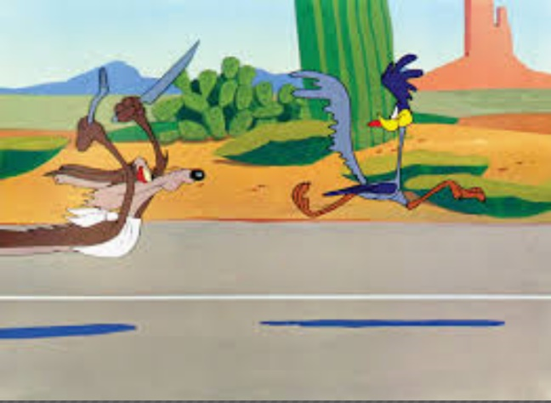Which has more kinetic energy, the Road Runner or the Coyote? Explain why.